Creator Portfolio CMS
MERN Stack Project Documentation
Student Name | John Vivek Paandi
Project Type | Full Stack MERN Application
Frontend | React + Vite
Backend / Database | Node.js, Express.js, MongoDB Atlas

1. Project Overview
The Creator Portfolio CMS is a full-stack MERN application built to manage and display creative portfolio projects. The application allows a user to add project information through a React form and view the saved projects as visual cards on the same page.
The project was designed with a dark, modern, visual-board interface inspired by creative portfolio and design inspiration websites. It includes a centered hero section, a styled project submission form, and a responsive masonry-style project grid.
Screenshot 1: Final UI / Home Page
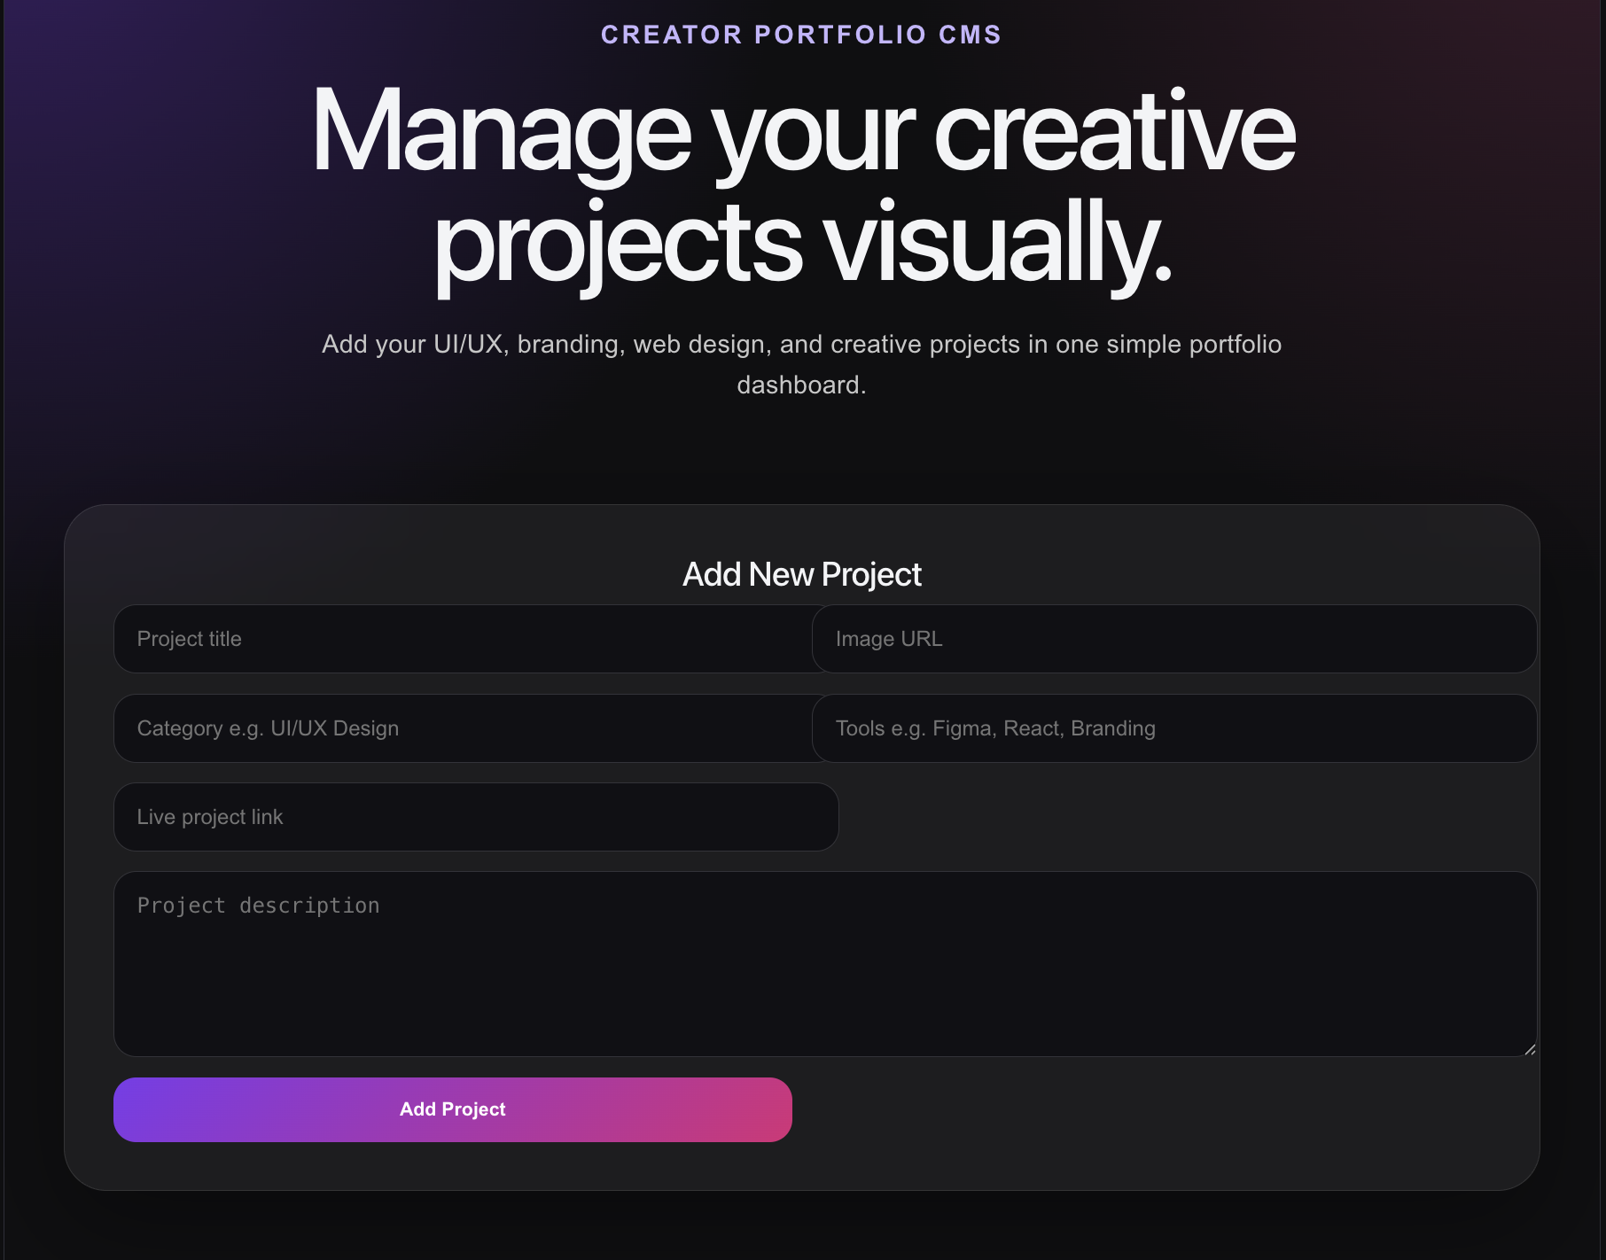

2. Technology Stack Used
Technology | Purpose | How it was used
React | Frontend UI | Created the form, project cards, and visual dashboard.
Vite | React development server | Used to create and run the frontend quickly on localhost:5173.
Node.js | Runtime environment | Used to run JavaScript on the backend.
Express.js | Backend framework | Created API routes for getting, adding, and deleting projects.
MongoDB Atlas | Database | Stored project data in a cloud MongoDB database.
Mongoose | Database connector | Connected Express backend to MongoDB and created the project schema.
Axios | API requests | Sent GET, POST, and DELETE requests from React to the backend.
CSS | Visual styling | Styled the layout, form, cards, spacing, and responsive UI.

3. Setup Process
Created the project folder: A main folder named creator-portfolio-cms was created on the Desktop.
Created the backend folder: A backend folder was created and initialized using npm init -y.
Installed backend packages: Installed express, mongoose, cors, and nodemon.
Created server.js: Built the Express server, connected MongoDB Atlas, and created API routes.
Created MongoDB Atlas cluster: Used MongoDB Atlas instead of local MongoDB because the system had low storage.
Added MongoDB connection string: Connected the backend to the portfolioCMS database using the Atlas connection URL.
Created React frontend: Used Vite to create a React project inside the frontend folder.
Installed Axios: Axios was installed to connect the React frontend with the backend API.
Styled the interface: App.css was updated with a centered layout, form styling, and visual project cards.
Changed backend port: The backend was changed from port 5000 to port 5050 to avoid access issues.
Screenshot 2: Project Folder Structure in VS Code
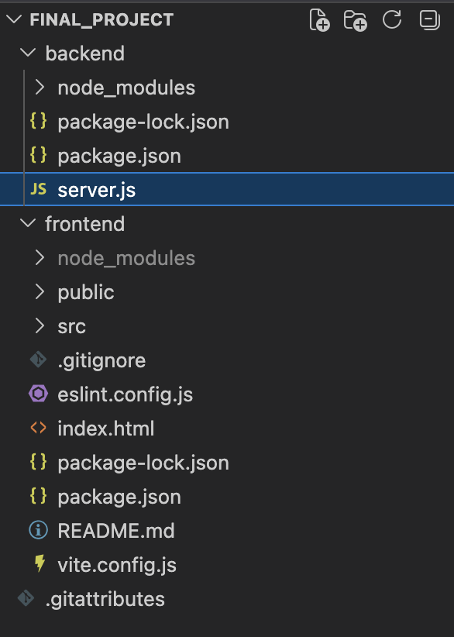
Screenshot 3: Backend Terminal Running
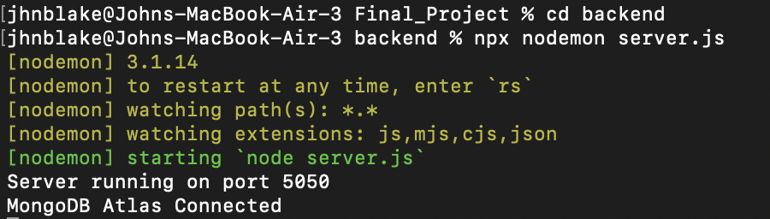

4. Backend Implementation
The backend was created using Node.js and Express. It connects to MongoDB Atlas using Mongoose. A Project schema was created with fields for title, image, category, tools, description, and link.
Main backend routes:
Method | Route | Purpose
GET | / | Checks whether backend is running.
GET | /api/projects | Fetches all saved projects.
POST | /api/projects | Adds a new project to MongoDB.
DELETE | /api/projects/:id | Deletes a selected project.

Screenshot 4: server.js Code
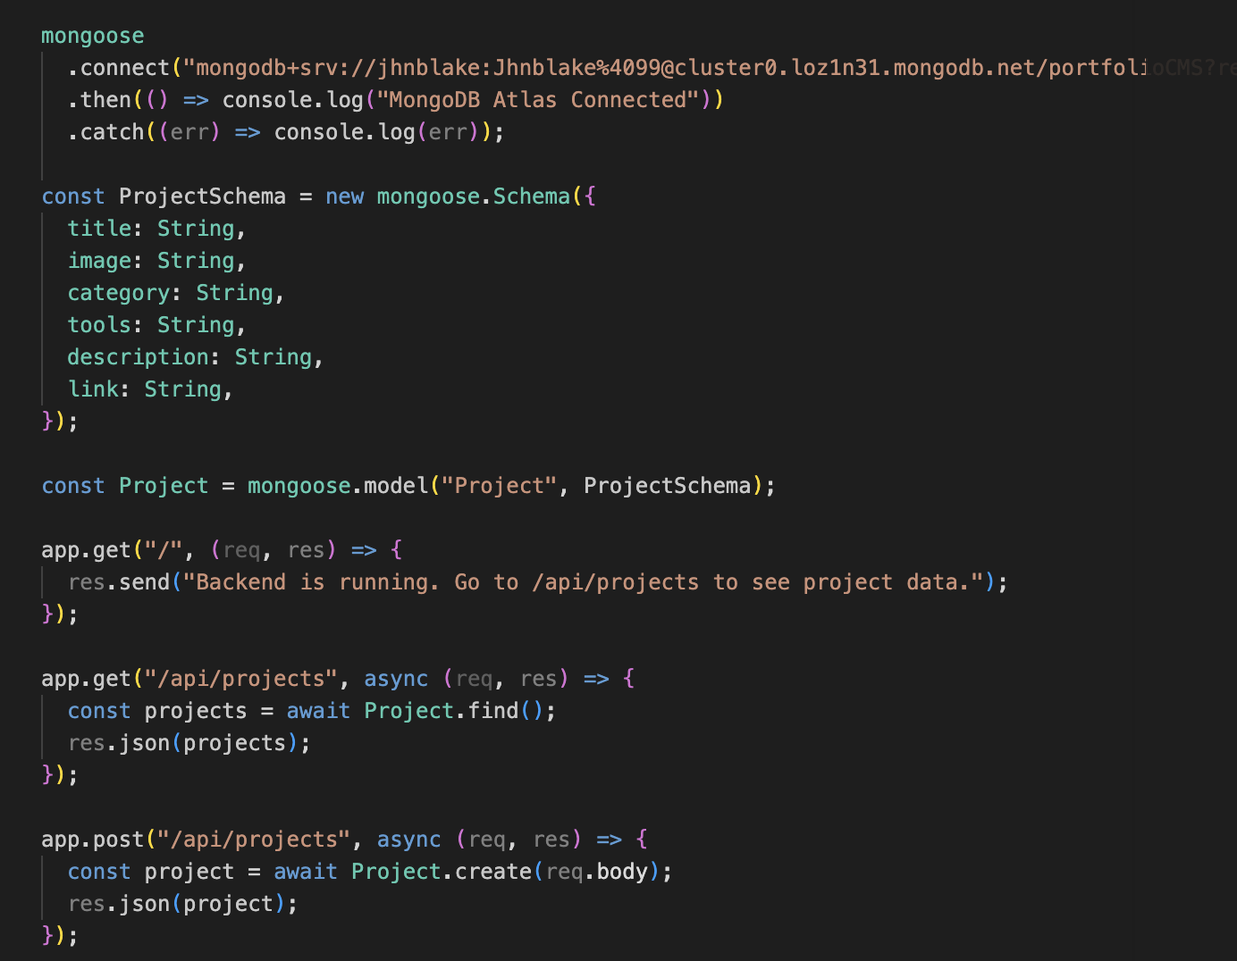

Screenshot 5: Backend API Test
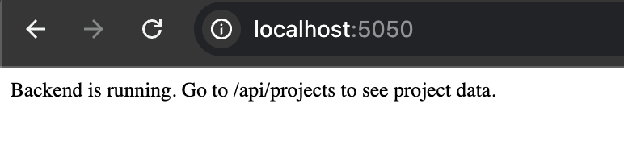

5. Frontend Implementation
The frontend was created using React and Vite. The UI contains a hero section, an input form, and a project display section. The form sends project details to the backend, and the project cards update after data is saved.
- Centered hero text and description
- Project input form with fields for title, image URL, category, tools, description, and live link
- Add Project button
- Responsive visual card layout
- Delete button for each project
- Data persistence through MongoDB Atlas
Screenshot 6: App.jsx Code

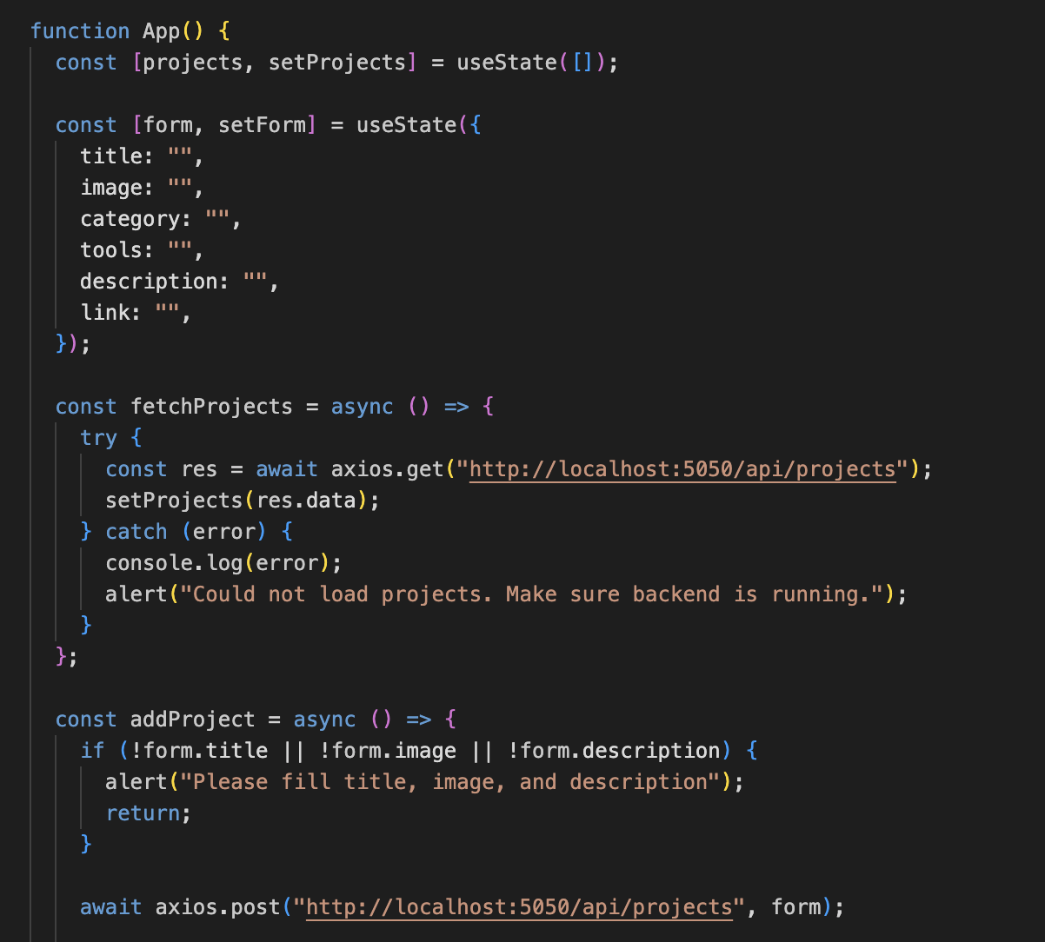
Screenshot 7: App.css Code
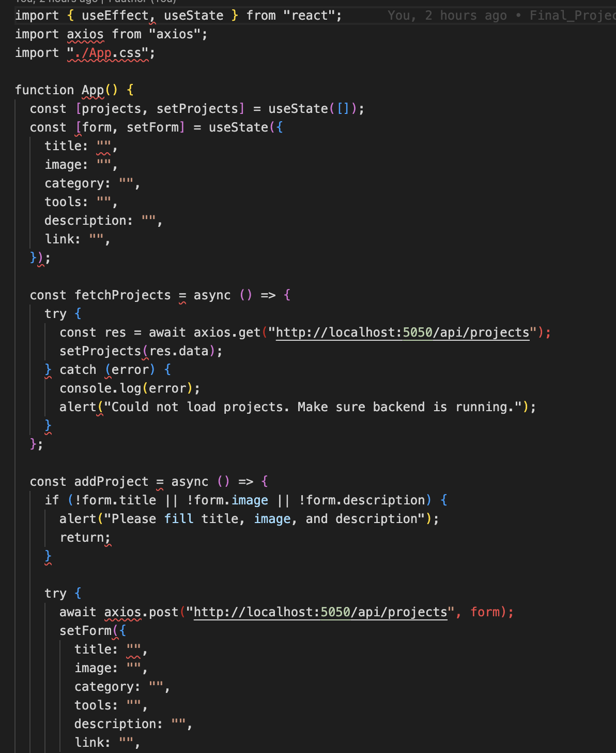

6. Testing the Project
Test Case | Action Taken | Expected Result
Backend connection | Opened http://localhost:5050/api/projects | Returned an empty array or saved project JSON.
Add project | Filled the form and clicked Add Project | Project card appeared on the frontend.
Data persistence | Refreshed the frontend page | Saved project stayed on the page.
Delete project | Clicked Delete on a project card | Project was removed from the page and database.
MongoDB storage | Checked MongoDB Atlas collection | Project data appeared in the database.
Screenshot 8: Form Filled Before Adding Project
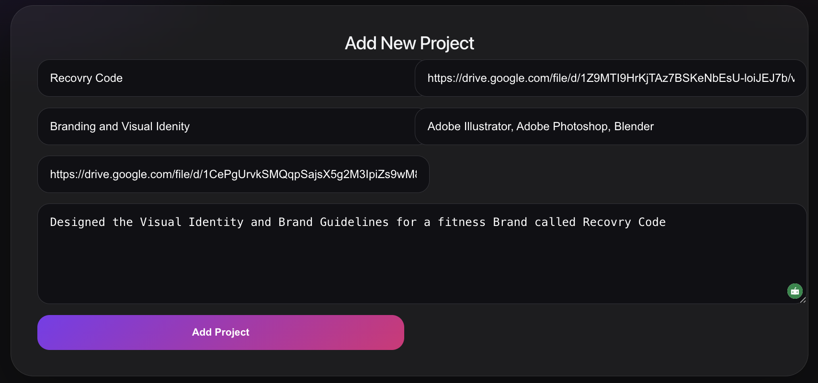
Screenshot 9: Project Card Displayed After Adding
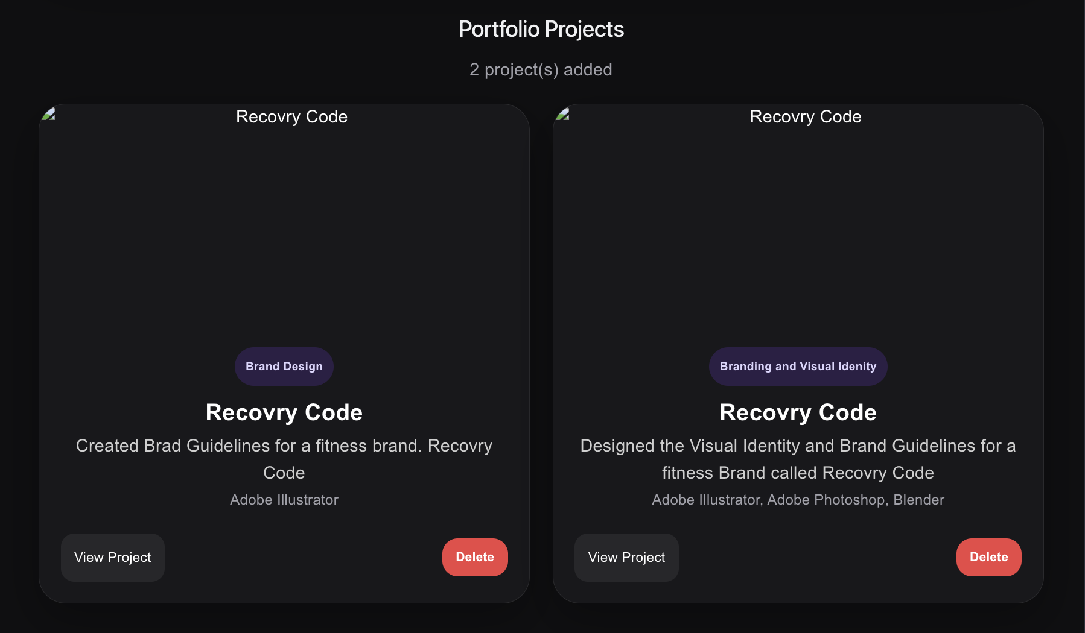
Screenshot 10: MongoDB Atlas Saved Data
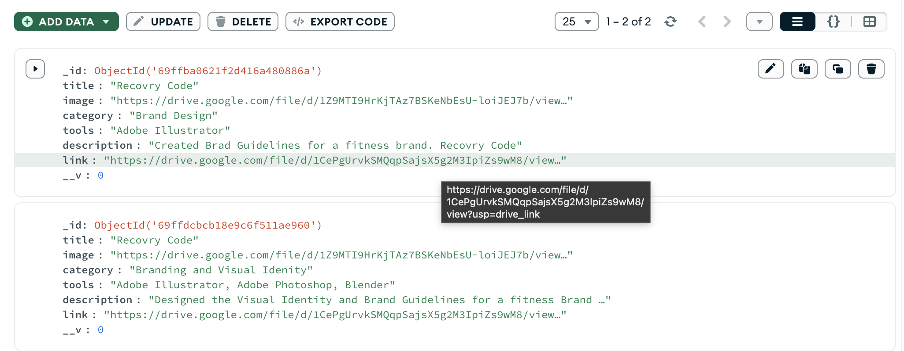

7. Conclusion
The Creator Portfolio CMS project successfully demonstrates a full-stack MERN workflow. The React frontend communicates with the Express backend using Axios, and the backend stores project data in MongoDB Atlas using Mongoose. The application supports adding, viewing, and deleting portfolio projects through a modern visual interface.

